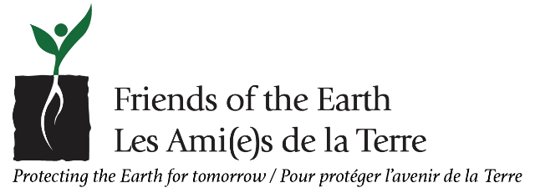

February 6, 2023
Environment Commission
Montreal Metropolitan Community
1002 Sherbrooke St. W., suite 2400
Montreal, Quebec H3A 3L6
Re: Hearings on the Plan métropolitain de gestion des matières résiduelles 2024-2031
Sirs and Madams,
Friends of the Earth Canada is a member of the 73-country federation of Friends of the Earth International addressing the most compelling environmental and social issues of our time. Plastic waste, with its impact on terrestrial and marine ecosystems, is certainly one of these compelling issues.
We would therefore like to avail ourselves of the hearings about the Plan métropolitain de gestion des matières résiduelles 2024-2031 to call for two measures which would greatly reduce the production of waste matter at its source:
1) Have flyer distributors switch from the current opt-out distribution system to an opt-in system whereby flyers would only be left on a doorstep if an authorization pictogram is posted up;
2) Ban the use of plastic bags or other plastic wrappers for such deliveries, given that a paper-and-plastic mix is NOT recyclable, and that sorting centres are unable to separate the two.
Furthermore, we recommend that regular inspections be instituted to enforce these two measures, as delinquent distributors have been known to ignore past regulations. High penalties for infractions should both dissuade corporate recidivism and cover the cost of the inspections themselves.
Given that the Greater-Montreal area is about to run out of landfill space and that flyers make up 11 to 20% of the sorting centres’ workload (per Montreal’s Consultation publique sur le contrôle des circulaires and the Médias Transcontinental S.E.N.C. c. Ville de Mirabel court case), these changes are most urgent and should be implemented as soon as possible.
Thank you for providing us with this opportunity to express our concerns.

Respectfully yours,

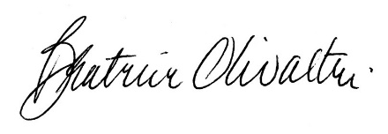
Beatrice Olivastri, CEO

